**Install the connector package**

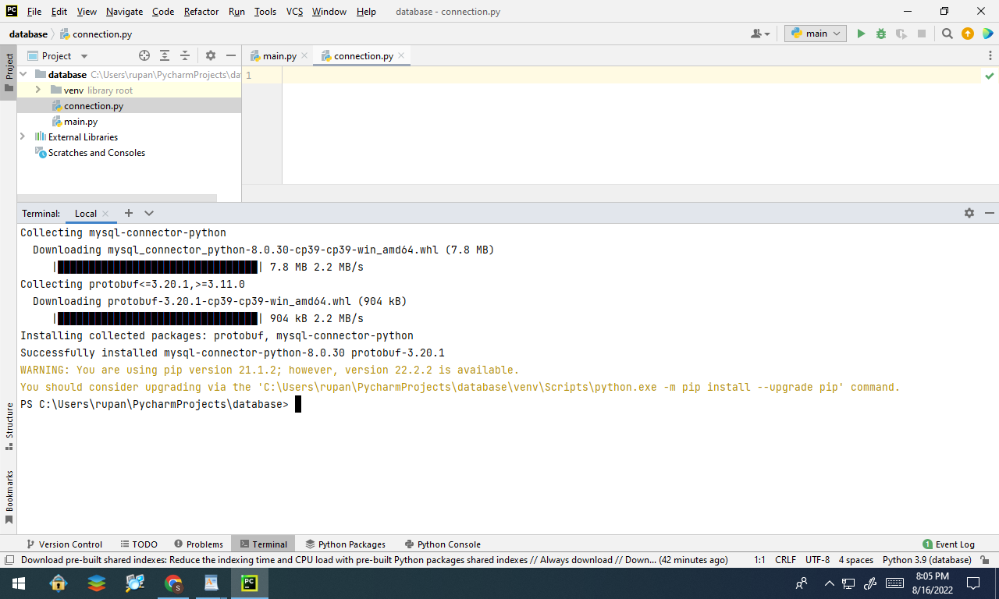

**Create a database user**

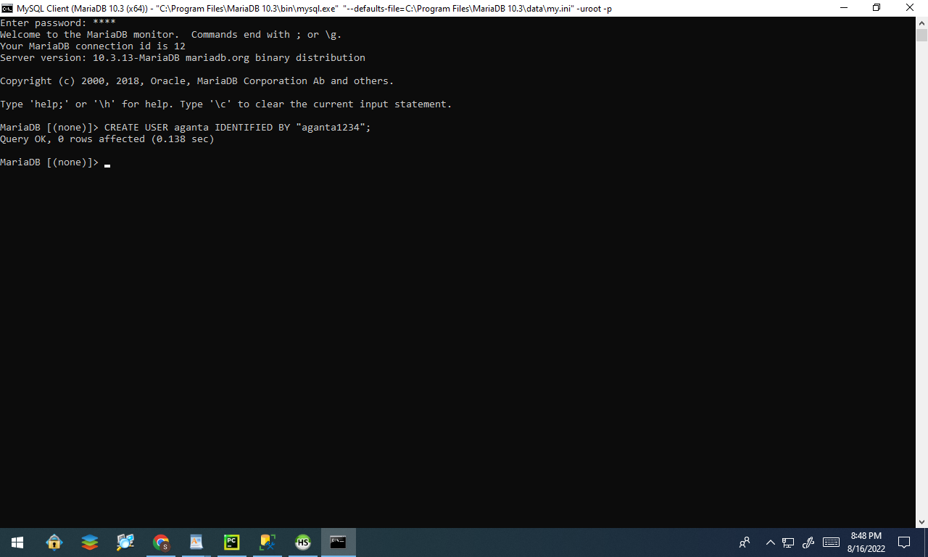

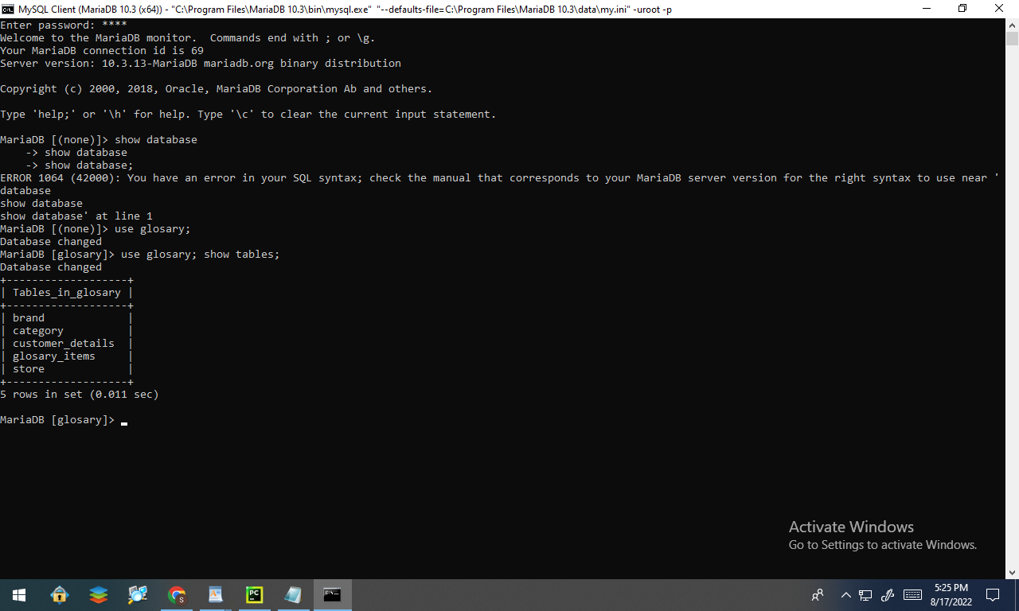

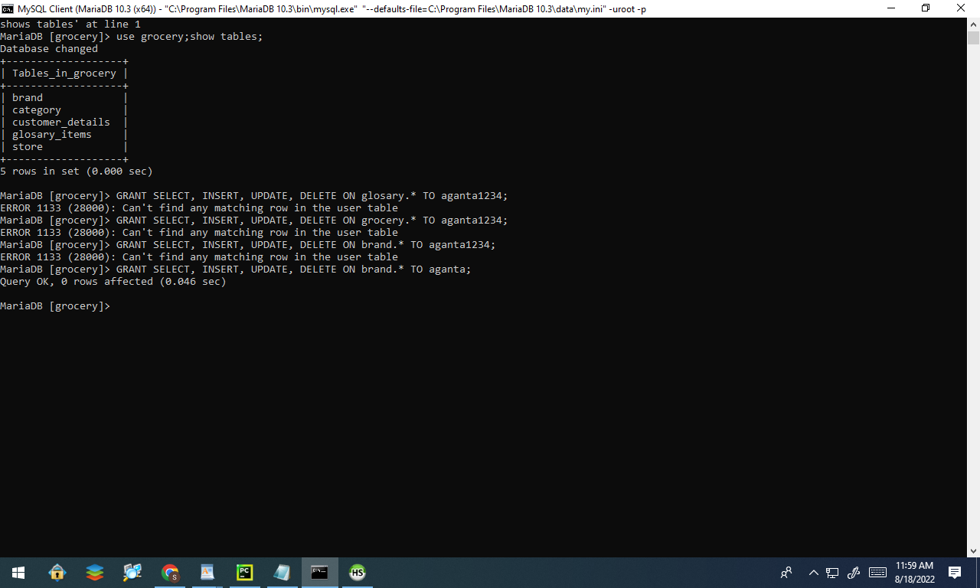

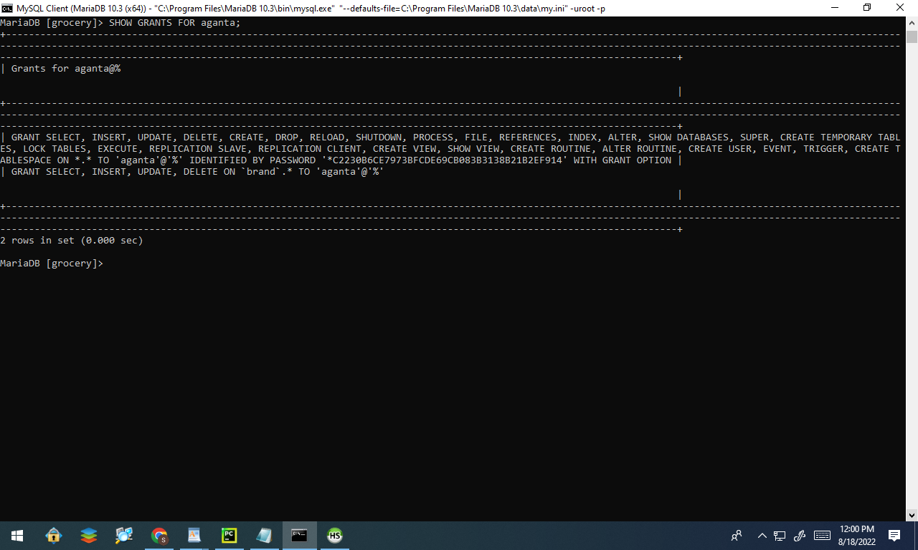

**Connecting to MySQL DB**

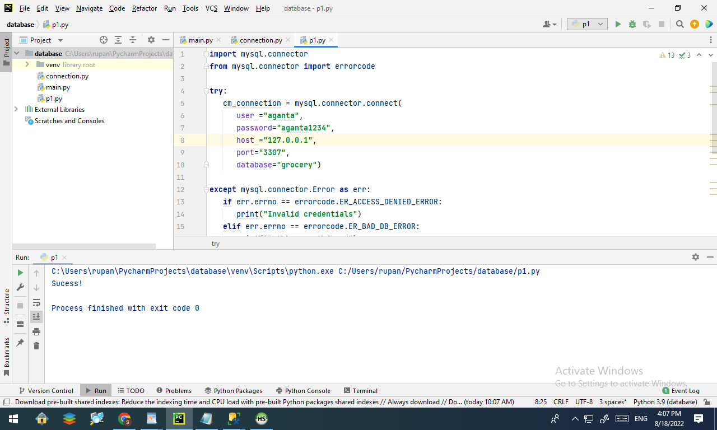

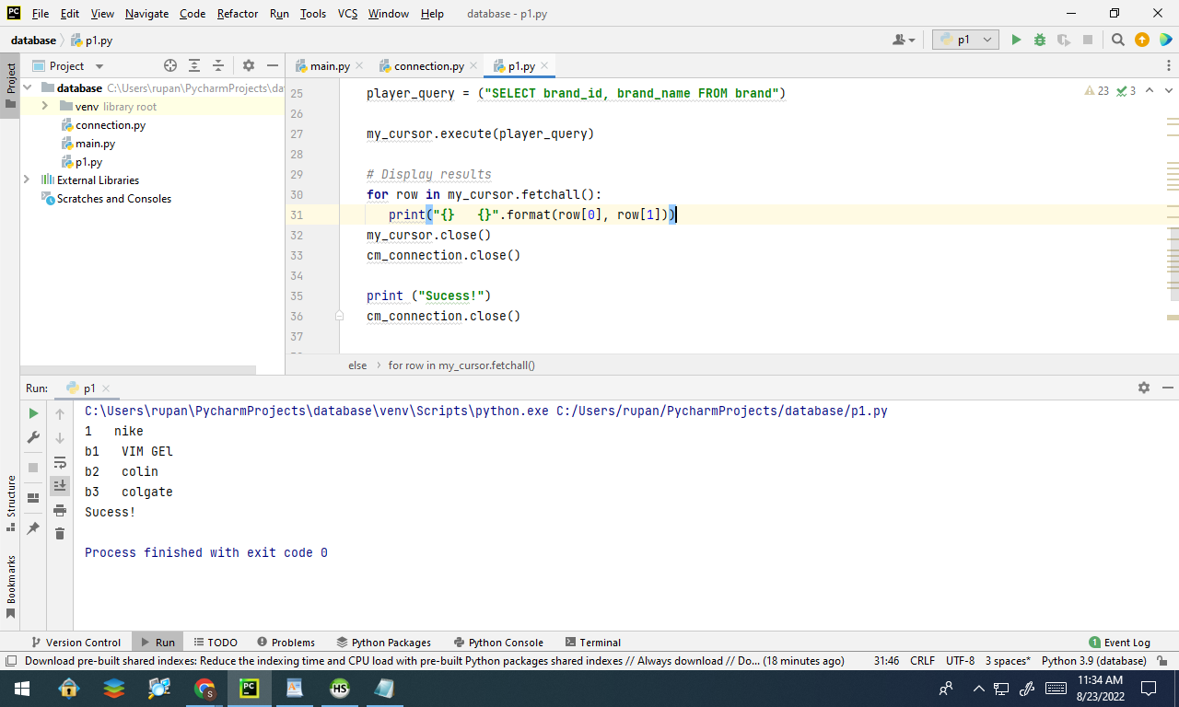

**All Query:**

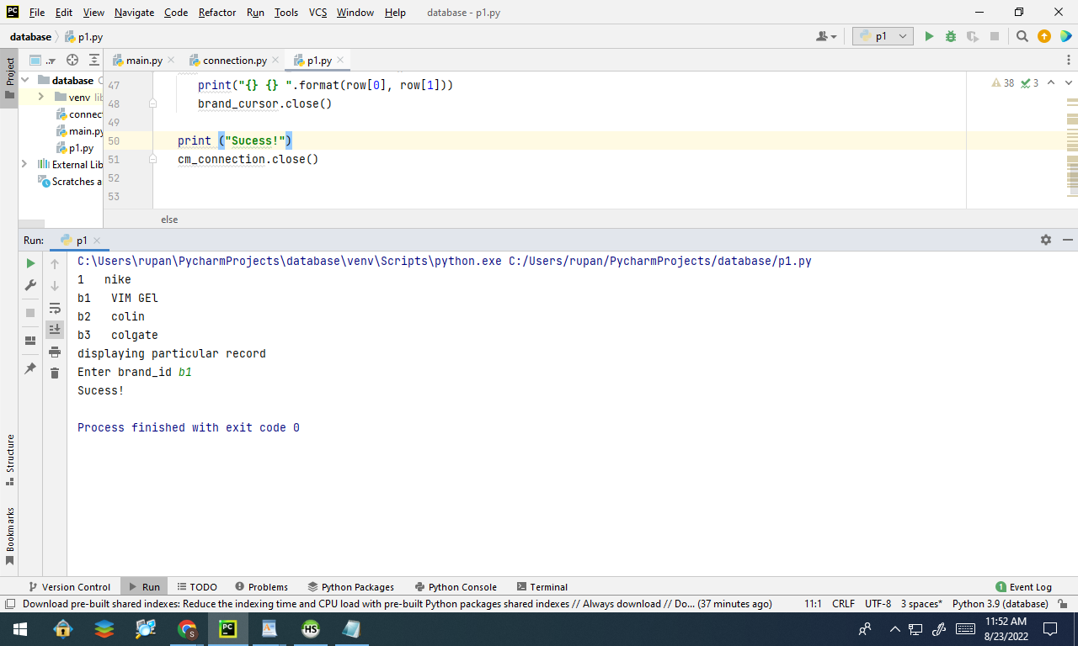

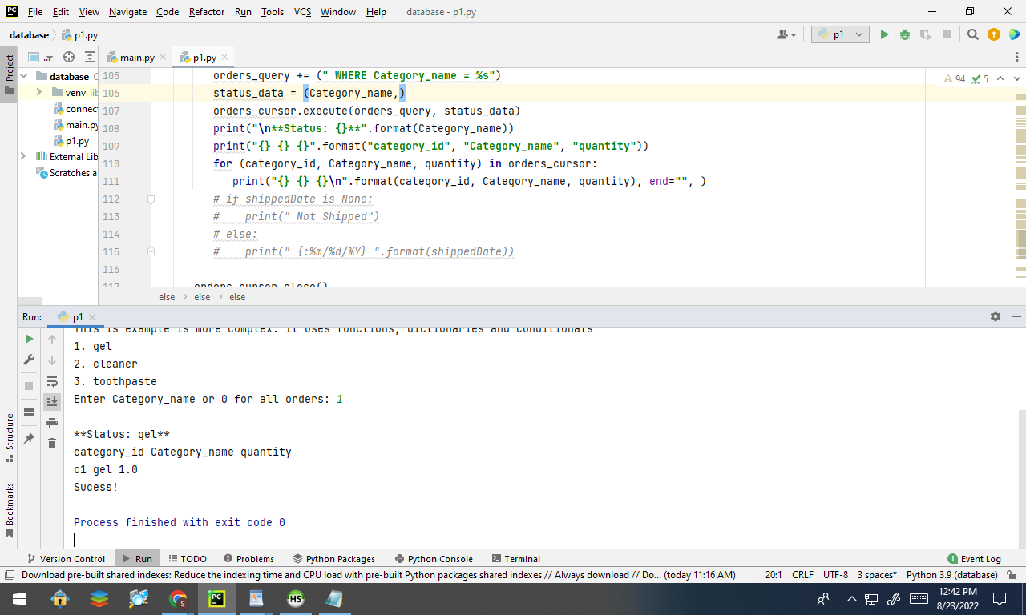

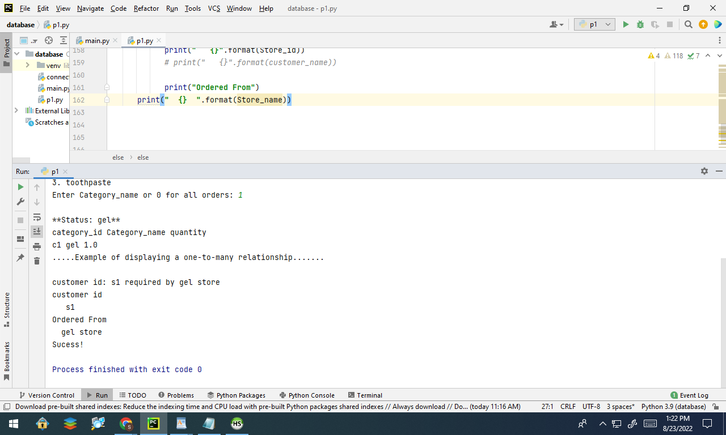

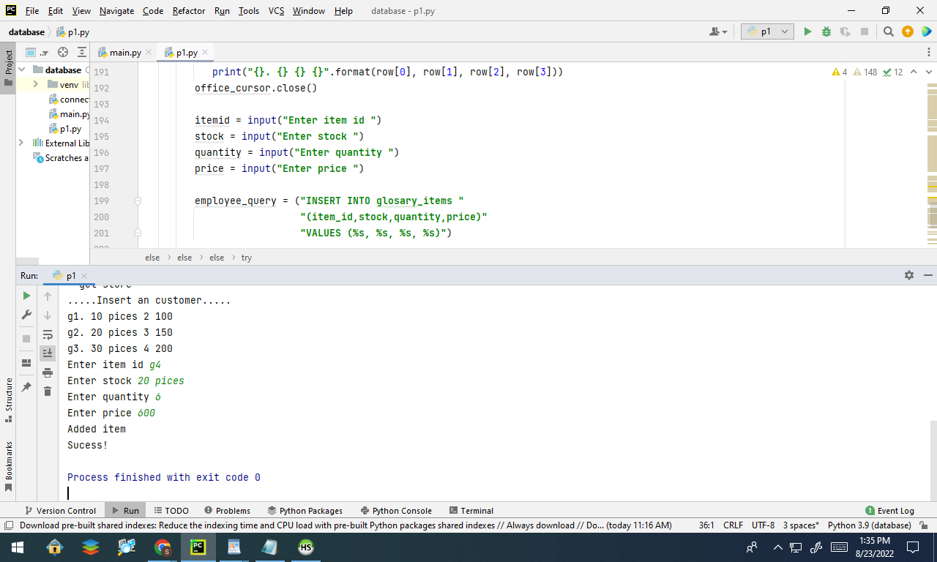

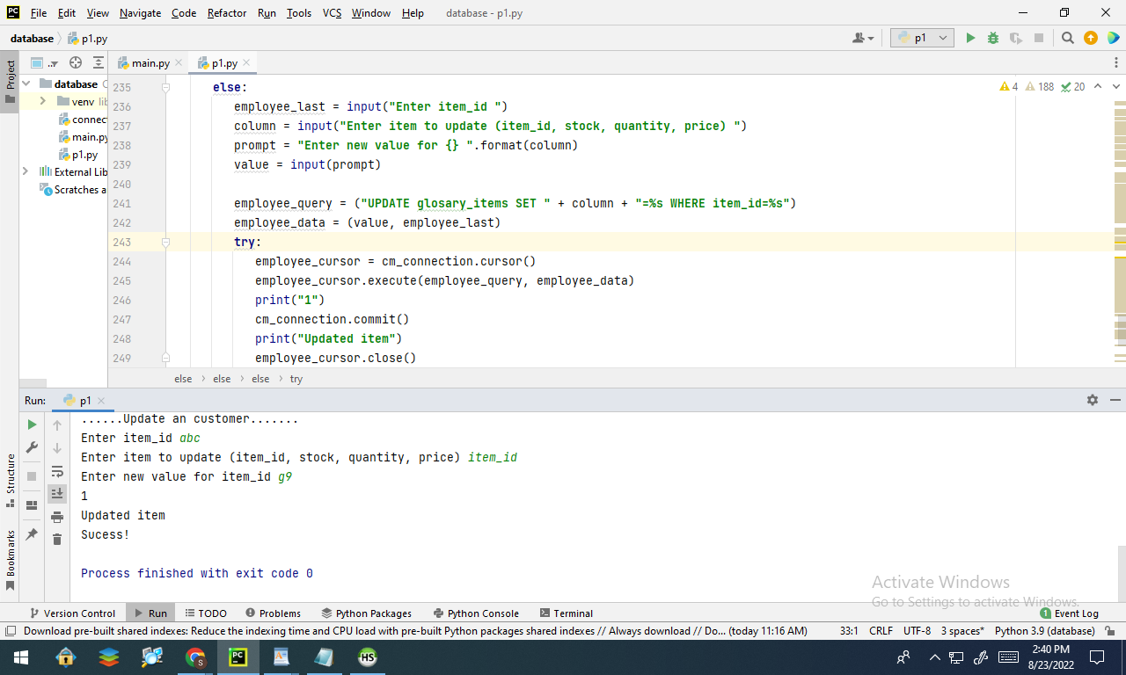

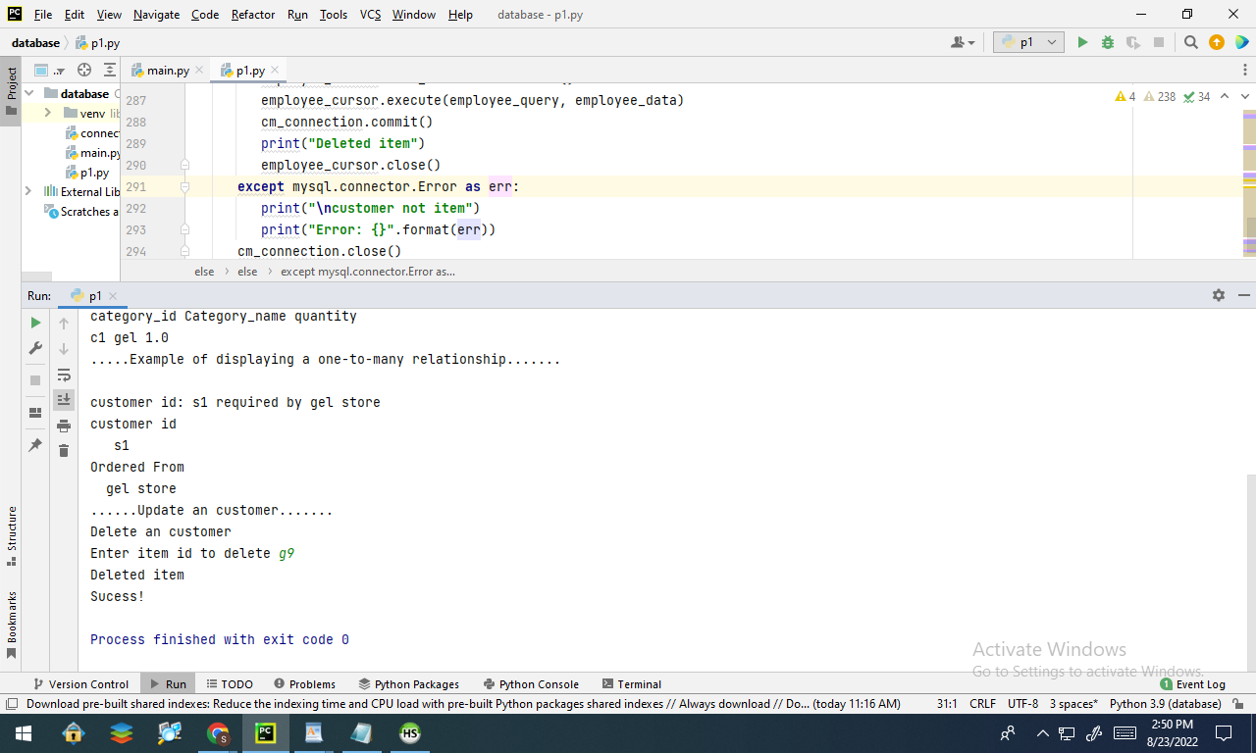

10 points for Internal comments – they must accurately describe each of the following:

The purpose of the program

The connection to the database

The creation of the cursor object

The SQL query string and execution

Ans::

The purpose of the program is grocery business for digitalization. The online grocery industry has expanded significantly over the past ten years, and the internet has had a significant impact on changing customer behavior. The ability to get everything needed with a single click or tap and have it delivered right to your door has not only started a trend, but it has also given online businesses more opportunities. It has shown significant growth and achieved great sales and gained more users.

For creating the database the python code is run with SQL in HeidiSQL platform. HeidiSQL is a dependable and very functional tool for using MariaDB. It can enable us to edit and browse the data, edit and create tables or schedule any events etc. The cursor is a type of temporary memory which is used for storing the database tables. The object tables which are created for the program are brands, category, customer details, grocery items and store.

Now, the queries which are executed in SQL are insert, update, delete etc. as shown in the picture above. The insert query helps to add new rows to the table. The update query helps to modify the data within the table. And the delete query is used for deleting the existing records in the database table. It is a one to many relationship. The one to many relationship may happen if any record from a table is related to one or many records in another table. Also in another table one record may not be related with more than one record in the previous table. In the above screenshot the outcome is shown.